**IOT PHASE_5**

**AIR QUALITY MONITERING**

**ABSTRACT:**

Air quality monitoring is of paramount importance in urban environments, where air pollution poses significant health risks. This paper presents the development and evaluation of an Internet of Things (IoT)-based air quality monitoring system designed to provide real-time, high-resolution data on air pollutants. The system incorporates a network of low-cost sensors deployed across a metropolitan area, enabling continuous monitoring and data collection.

The methodology involves the design and calibration of particulate matter (PM) and gas sensors, which are integrated into a centralized data collection platform. We conducted an extensive field evaluation of the system's performance, measuring its accuracy, precision, and response time in various environmental conditions. The data collected by our system was compared with reference-grade instruments to assess its reliability.

**INTRODUCTION:**

Air pollution is a pervasive environmental concern with far-reaching implications for public health, ecological well-being, and the quality of life in urban and industrialized areas. The deteriorating air quality in many regions is primarily driven by industrial emissions, vehicular exhaust, and a myriad of other anthropogenic activities. It is well-established that exposure to elevated levels of air pollutants, including fine particulate matter (PM2.5), volatile organic compounds (VOCs), and nitrogen dioxide (NO2), is associated with a multitude of adverse health effects, ranging from respiratory ailments to cardiovascular diseases and even premature mortality.

**BLOCK DIAGRAM:** 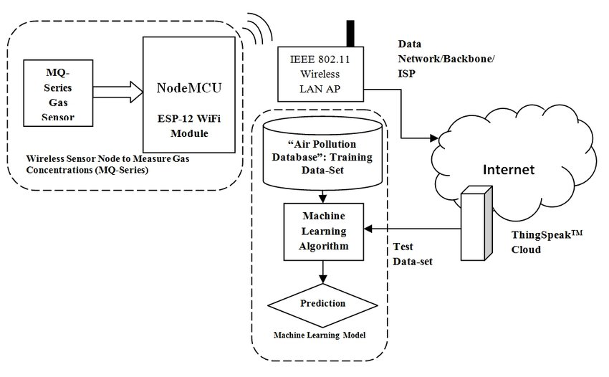

**IoT Monitoring System components:**

IoT-based air pollution monitoring systems comprise several components that work together to collect and analyze air quality data. The components include:

* **Sensors**: Sensors are the primary components of IoT-based air pollution monitoring systems. They measure various air quality parameters such as particulate matter, carbon monoxide, sulfur dioxide, and nitrogen oxides. The sensors can be classified into two categories: physical and chemical sensors. Physical sensors measure parameters such as temperature, humidity, and pressure, while chemical sensors measure air pollutants.
* **Microcontroller:** The microcontroller is the brain of IoT-based air pollution monitoring systems. It receives data from the sensors, processes it, and sends it to the cloud server. The microcontroller is usually a microprocessor such as Arduino, Raspberry Pi, or similar devices.
* **Communication Module:** The communication module is responsible for transmitting data from the microcontroller to the cloud server. Communication modules can use various wireless technologies such as Wi-Fi, Bluetooth, or cellular networks.
* **Cloud Server:** The cloud server is a centralized platform for storing, analyzing, and sharing air quality data. It collects data from the communication module and stores it in a database. The cloud server also provides web and mobile applications for users to access the data.
* **Power Supply:** IoT-based air pollution monitoring systems require a power supply to operate. In case of permanent installations external power supply is provided and batteries are provided for portable devices.
* **Enclosure:** The enclosure is the outer covering that protects the components from environmental factors such as dust, water, and temperature.

**Benefits of IoT-Based Air Quality Monitoring:**

* **Real-Time Monitoring:** IoT-based systems provide continuous and real-time air quality data, allowing for prompt responses to deteriorating air quality.
* **Data Accuracy:** Sensors used in IoT systems are typically more accurate and reliable than traditional monitoring methods.
* **Data Accessibility:** Data is readily accessible to the public, researchers, and policymakers, promoting transparency and informed decision-making.
* **Identifying Pollution Sources**: These systems can help identify specific sources of pollution, enabling targeted interventions to mitigate air quality issues.
* **Public Awareness**: By making air quality data accessible, IoT-based systems raise public awareness about the importance of air quality and encourage individuals to take measures to protect their health.
* **Environmental Policy**: Governments and local authorities can use the data collected to formulate effective environmental policies and regulations.

**SENSOR USED IN AIR QUALITY MONITERING:**

In a air quality monitoring system, various sensors are used to measure and monitor different aspects of air quality. Some of the common sensors used in such systems include:

* **Particulate Matter (PM) Sensors**: These sensors measure the concentration of airborne particles, including PM2.5 and PM10, which are fine and coarse particulate matter. They are crucial for assessing air pollution and its impact on human health.

**PIN DIAGRAM:**

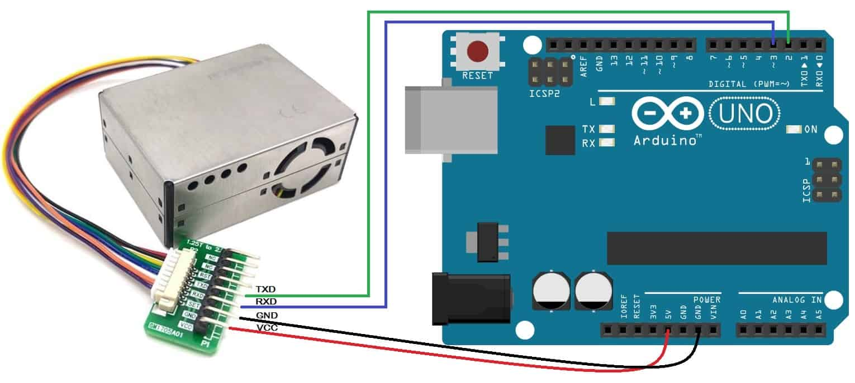

**PIN CONFIGURATION:**

**1.Power Supply Pins:**

VCC or +5V: Connect to a 5-volt power source.

GND or 0V: Connect to the ground or 0-volt reference.

**2.Data Output Pins**

**3.Communication Interface Pins**

**4.Control Pins**

**Gas Sensors**: Gas sensors are used to detect and quantify the levels of various gases in the air, including.

**PIN DIAGRAM:**

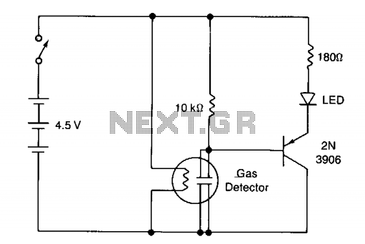

**PIN CONFIGURATION:**

1.**VCC (Voltage Supply):** This pin is used to provide power to the sensor. It is typically connected to a voltage source (e.g., +5V or +3.3V).

2.**GND (Ground):** This pin is connected to the ground (0V) of the power supply.

3.**Signal Output:** This pin provides an analog or digital signal that represents the concentration of the detected gas. The type of signal (analog or digital) and the voltage levels can vary between different sensors.

4.**Heater Control (optional):** Some gas sensors have an integrated heater to improve sensitivity and reduce response time. If present, this pin is used to control the heater element.

**Carbon Dioxide (CO2) Sensors:** Measure carbon dioxide levels, which can indicate indoor air quality and ventilation effectiveness.

**PIN DIAGRAM:**

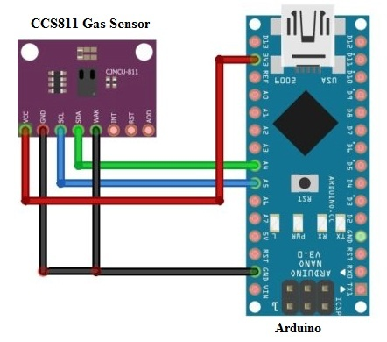

**PIN CONFIGURATION:**

1.**VCC (Power Supply):** This pin is used to provide the sensor with the required voltage, typically between 4.5V and 5.5V.

2**.GND (Ground):** This pin is connected to the ground or 0V reference of the power supply.

3.**Analog Output (Voltage Output):** Many NDIR CO2 sensors provide an analog voltage output that varies with the concentration of CO2. This pin is connected to an analog input of a microcontroller or data acquisition system.

4.**Digital Output (Optional):** Some CO2 sensors have a digital output that provides a binary signal (e.g., high or low) indicating a specific CO2 threshold has been reached. This can be useful for simple threshold-based applications.

5.**UART or I2C Communication (Optional):** More advanced CO2 sensors may feature UART or I2C communication interfaces, allowing for digital communication with a microcontroller or computer.

6.**On-Board Heater Control (Optional):** Some sensors have a pin to control an internal heater. This is used to maintain a stable sensor temperature, which is crucial for accurate CO2 measurements.

**Carbon Monoxide (CO) Sensors:** Detect the presence of carbon monoxide, a toxic gas produced by incomplete combustion of carbon-containing fuels.

**PIN DIAGRAM:**

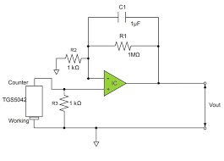

**PIN CONFIGURATION:**

1.**VCC or VDD:** This is the power supply pin. You would typically connect this pin to a suitable voltage source, which is often in the range of 3.3V to 5V, depending on the sensor's specifications.

2.**GND:** This is the ground or common reference pin. Connect it to the ground of your power supply.

3.**Signal Out or Data Out:** This pin provides the analog or digital output from the sensor, representing the detected CO level. The signal format (analog or digital) can vary between different sensor models. You may need to connect this pin to a microcontroller or other data acquisition device.

4.**Heater Control (optional):** Some CO sensors include a heater element to improve sensor performance. This pin allows you to control the heater. If present, you may need to connect this to a digital output pin on your microcontroller to turn the heater on or off.

**Nitrogen Dioxide (NO2) Sensors**: Measure the concentration of NO2, a common air pollutant produced by combustion processes.

**PIN DIAGRAM:**

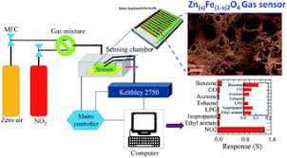

**PIN CONFIGURATION:**

**1. Power Supply:** Most NO2 sensors require a power supply. This pin is usually labeled as Vcc or Vdd and is used to provide the sensor with the necessary voltage (often 3.3V or 5V).

**2. Ground**: This pin is labeled GND and is used to connect the sensor to the ground or 0V reference of your circuit.

**3. Analog Output:** Many NO2 sensors provide an analog voltage output that represents the concentration of NO2 gas. This pin is often labeled as AO or similar.

**4. Digital Output**: Some NO2 sensors might have a digital output pin, often in the form of a UART (serial) or I2C interface. This digital output provides a more precise and easily processed measurement of NO2 levels.

**5.Heater Control:** To improve sensor performance and reduce the impact of temperature changes, some NO2 sensors have a pin for heater control. This pin might be labeled as H or smilar.

**6. Reference or Nulling:** Some NO2 sensors have a reference or nulling pin that allows you to zero or calibrate the sensor. This pin might be labeled as REF or similar.

**7. LED Indicator**: Some sensors have an LED indicator pin to signal the status or an alert condition. It might be labeled as LED or similar.

**Ozone (O3) Sensors**: Monitor ozone levels, which can be both beneficial in the upper atmosphere and harmful at ground level.

**PIN DIAGRAM:**

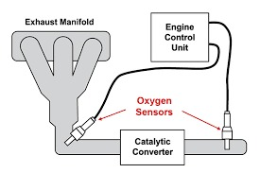

**PIN CONFIGURATION:**

**1.Power Supply Pins:**

VCC or +5V: Connect to a 5-volt power source.

GND or 0V: Connect to the ground or 0-volt reference.

**2.Analog Output Pin:**Ozone sensors often provide an analog output signal that varies with the concentration of ozone. This pin is typically labeled as "Analog Out" or similar.

**3.Digital Output Pin:**

Some ozone sensors also provide a digital output to indicate ozone levels exceeding a certain threshold. This pin may be labeled as "Digital Out" or similar.

**4.Heater Control Pins:**

Ozone sensors may have pins for controlling an internal heater element. Maintaining a specific temperature is often necessary for sensor stability and accuracy.

**5.Reference Voltage Pin:**

Some sensors may have a reference voltage pin for calibration or for setting the desired full-scale range of the analog output.

**6.Ground Pin:**

In addition to the general ground pin (GND), there might be a separate ground pin for the analog and digital sections of the sensor, depending on the sensor design.

**7.Configuration and Control Pins:**

Depending on the sensor, there may be pins for configuring the sensor settings, such as calibration, sensitivity, or mode selection.

**8.Serial Communication Pins (optional):**

If the sensor has digital or serial communication capabilities, it may have pins for transmit (TX) and receive (RX) lines, or use standard communication protocols like I2C, SPI, or UART.

**9.LED Indicator Pins:**

Some sensors include LED indicator pins for showing the operational status of the device.

**10.Mounting or Enclosure Pins:**

Depending on the sensor's design, there may be pins or mounting holes to attach the sensor securely to an enclosure or housing.

**11.Grounding and Shielding Pins:**

For sensors used in industrial or electrically noisy environments, there may be grounding or shielding pins toreduce interference.

**Sulfur Dioxide (SO2) Sensors**: Measure sulfur dioxide concentrations, typically produced by industrial processes and combustion of sulfur-containing fuels.

**PIN DIAGRAM:**

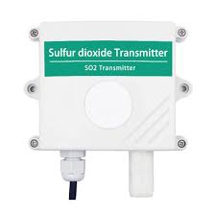

**PIN CONFIGURATION:**

**1.Power Supply Pins:**

VCC or +5V: Connect to a 5-volt power source.

GND or 0V: Connect to the ground or 0-volt reference.

**2.Analog Output Pin:**

Many SO2 sensors provide an analog output signal that varies with the detected concentration of sulfur dioxide. This pin is often labeled "Analog Out."

**3.Digital Output Pin:**

Some SO2 sensors may offer a digital output to indicate the presence or concentration of SO2 exceeding a specific threshold. This pin might be labeled "Digital Out" or similar.

**4.Heater Control Pin:**

SO2 sensors often have an internal heater to maintain a specific temperature for accurate measurements. The heater control pin allows you to control the heater element.

**5.Ground Pin:**

In addition to the general ground pin (GND), there may be a separate ground pin for the analog and digital sections of the sensor

**VOC (Volatile Organic Compounds) Sensors**: These sensors detect organic compounds that can evaporate into the air, contributing to indoor air pollution.

**PIN DIAGRAM:**

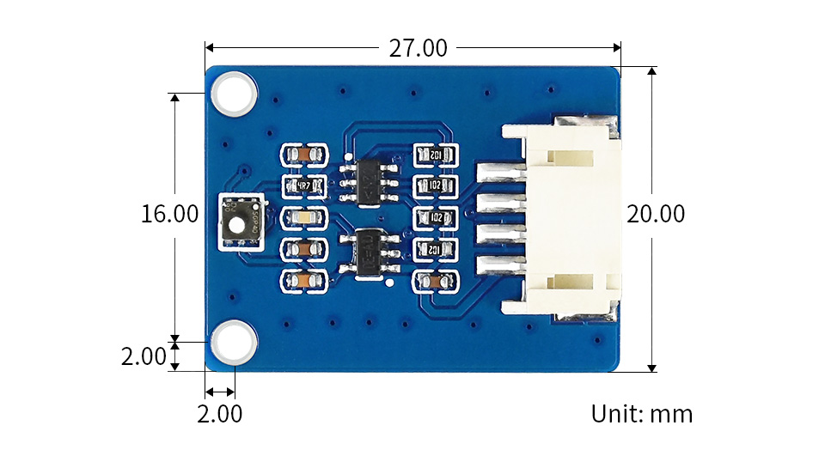

**PIN CONFIGURATION:**

**1.Vcc or VDD**

**2.GND**

**3.Analog Output Pin**

**4.Digital Output Pin**

**5.Heater Pin**

**6.Reference Pin**

**Temperature and Humidity Sensors:** These sensors help assess comfort and indoor air quality. Maintaining the right

temperature and humidity levels is essential for human health and comfort.

**PIN DIADRAM:**

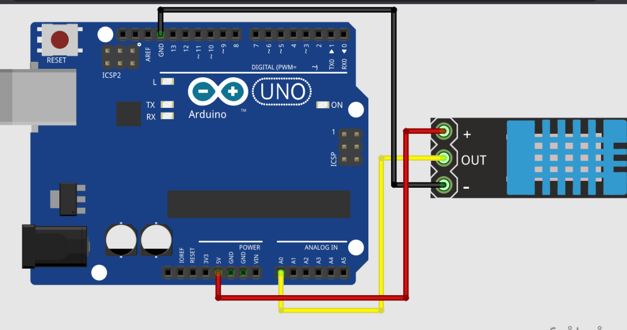

**PIN CONFIGURATION:**

**1.VCC or Power Supply:**

Connect this pin to a 3.3V or 5V power supply, depending on the sensor's specifications.

**2.Data Pin**

**3.Ground (GND):**

Connect this pin to the ground (0V) reference of your power supply.

**Pressure Sensors:** Pressure sensors can be used to measure barometric pressure, which can influence air quality and weather patterns.

**UV Sensors:** UV sensors can measure the intensity of ultraviolet radiation, which can impact air quality and human health.

**Noise Level Sensors**: These sensors can monitor ambient noise levels, which may affect overall well-being.

**PIN DIAGRAM:**

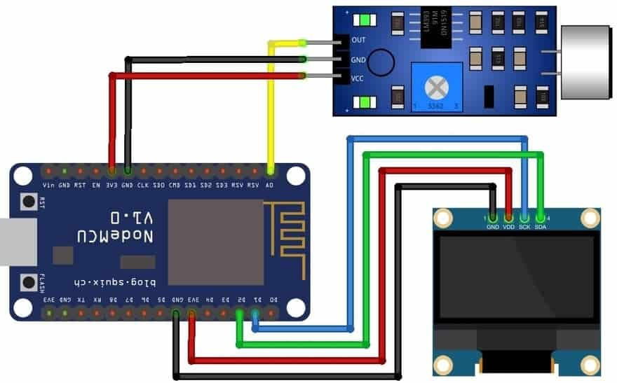

**PIN CONFIGURATION:**

**1.Power Supply Pins:**

VCC or +5V: Connect to a 5-volt power source.

GND or 0V: Connect to the ground or 0-volt reference.

**2.Analog Output Pin**

**3.Digital Output Pin**

**4.Filter or Weighting Pins**

**Weather Sensors:** Some air quality monitoring systems include weather sensors to measure parameters like wind speed and direction, precipitation, and temperature, as these can influence air quality.

**PIN DIAGRAM:**

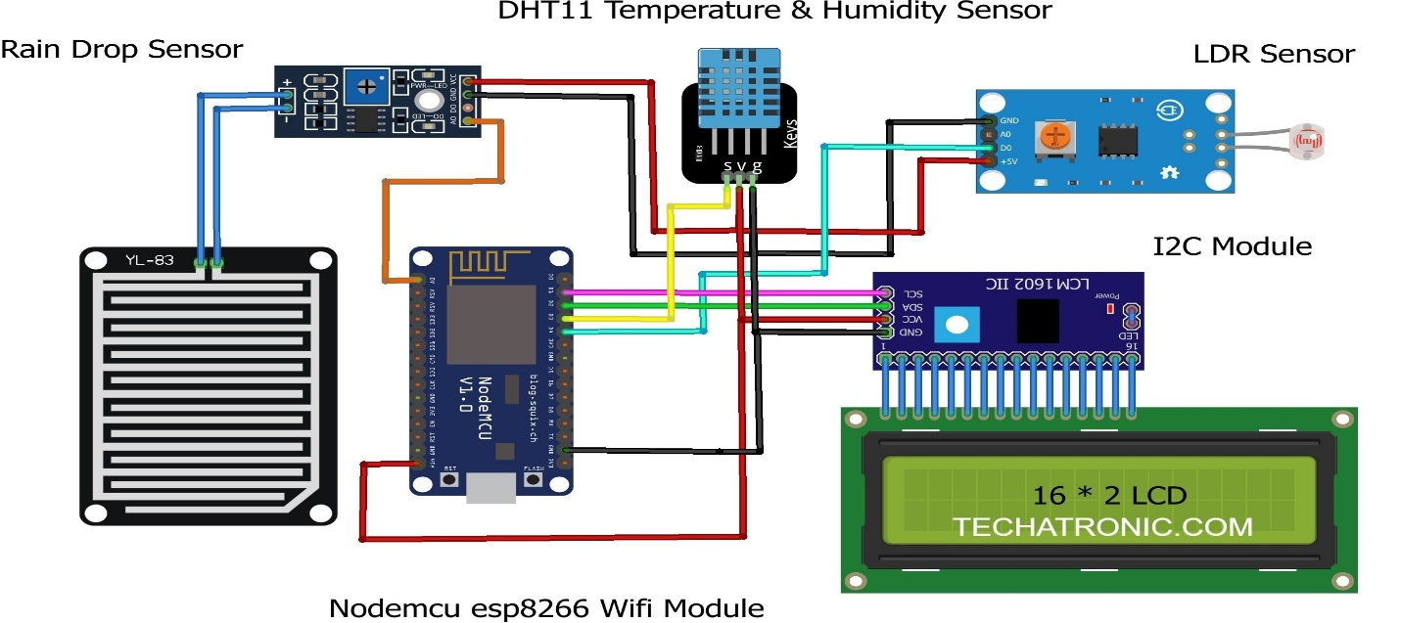

**PIN CONFIGURATION:**

**1.Temperature Sensor (e.g., DS18B20):**

**2.Data Pin**

**3.VCC (Power)**

**4.GND (Ground)**

**5.Humidity Sensor (e.g., DHT22, DHT11):**

**6.Barometric Pressure Sensor (e.g., BMP180, BMP280):**

**7.Wind Speed and Direction Sensor:**

**8.Rain Gauge Sensor**

**Particle Counters**: These sensors provide detailed information on the size distribution of particles in the air, helping to distinguish between different types of particulate matter.

**PIN DIAGRAM:**

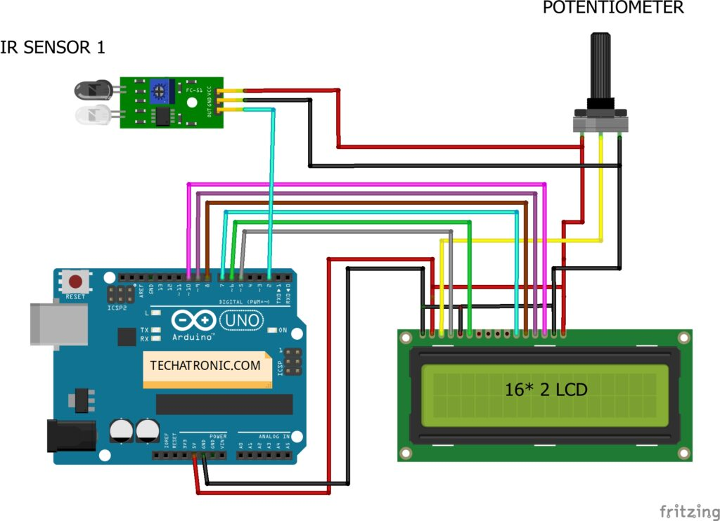

**PIN CONFIGURATION:**

**1.Reset Button/Signal:**

This button or input allows you to reset the counter to zero or a predefined starting value.

**2.Increment Button/Signal:**

This button or input allows you to manually increment the count each time the button is pressed or when an external signal is received.

**3.Display:**

The display typically shows the count value. It can be a digital numeric display or another type of indicator.

**4.Power Supply Pins:**

VCC or +5V: Connect to a 5-volt power source.

GND or 0V: Connect to the ground or 0-volt reference.

**5.Buzzer or Sound Output (optional):**

Some practice counters may have a pin for connecting a buzzer or speaker to provide an audible alert or confirmation when the count is incremented.

**GPS (Global Positioning System) Modules**: GPS modules can be integrated into air quality monitoring systems to record the location of measurements, allowing for spatial analysis of air quality data.

These sensors are typically integrated into air quality monitoring stations and networks to provide real-time data and long-term trends, helping governments, organizations, and individuals make informed decisions regarding air quality and pollution control. The choice of sensors used in a particular system depends on the specific air quality parameters of interest and the environmental conditions in the monitoring area.

**PIN DIAGRAM:** 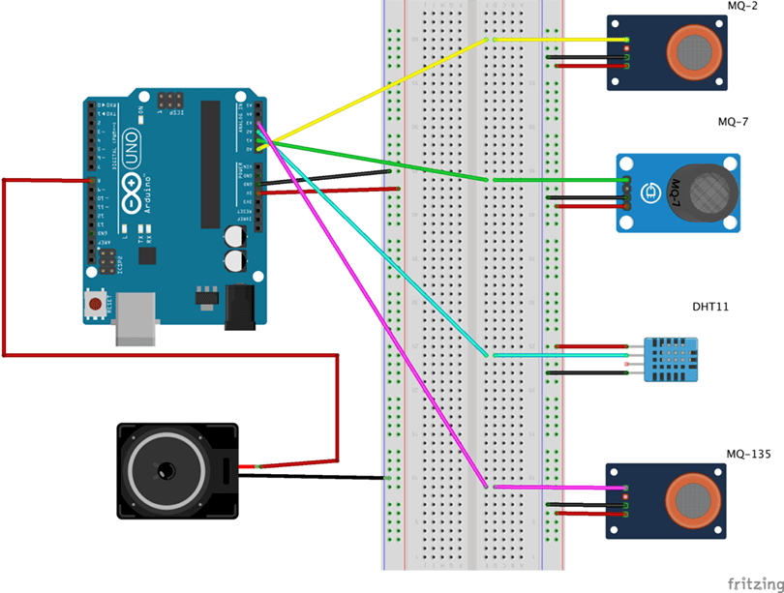

**PIN CONFIGURATION:**

The pin configuration for air quality monitoring systems can vary depending on the specific sensors and components used in the system. However, I can provide a general outline of the types of pins you might encounter when interfacing with sensors commonly used in air quality monitoring. Keep in mind that specific sensors may have different pin configurations, and you should refer to the datasheets or user manuals for individual sensors for precise details.

**1.Power Supply Pins:**

VCC or +5V: Connect to a 5-volt power source.

GND or 0V: Connect to the ground or 0-volt reference.

**2.Analog Output Pins**:

Some sensors provide analog output signals that vary in voltage or current to represent the measured data. These pins are labeled according to the specific sensor.

**3.Digital Output Pins:**

Many modern air quality sensors provide digital output in the form of I2C, SPI, UART, or GPIO pins.

**4.Communication Interface Pins:**

If the sensor communicates via a specific protocol like I2C or SPI, it will have pins for data (SDA, MOSI, etc.), clock (SCL, SCK, etc.), and possibly other control lines (e.g., chip select).

**5.Interrupt Pins:**

Some sensors have pins for generating interrupts when specific conditions are met, such as when air quality exceeds a certain threshold.

**6.Calibration Pins:**

Some sensors may have pins or connectors for calibration or adjustment purposes.

**7.Heater Control Pins:**Some air quality sensors, particularly those for measuring volatile organic compounds (VOCs), may have pins for controlling an internal heater element to improve sensor performance.

**8.Reference Voltage Pins:**

In some cases, you may need to provide an external reference voltage to the sensor for calibration purposes.

**9.UART or Serial Communication Pins:**

If the sensor communicates via UART or serial communication, it will have transmit (TX), receive (RX), and ground (GND) pins.

**10.LED Indicator Pins:**

Some sensors have built-in LED indicators to show the device's operational status.

**11.Shielding and Grounding Pins:**

For sensors used in industrial or electromagnetic noisy environments, there may be shielding or grounding pins to reduce interference.

**12.Auxiliary Pins:**

Depending on the sensor and its features, there might be additional pins for specific functions.

Please note that the pin configuration can vary significantly from one sensor to another. It's crucial to refer to the datasheets, user manuals, or documentation provided by the sensor manufacturer to get precise information about the pin configuration for a specific air quality sensor you are using.

**PYTHON PROGRAM:**

import serial

import time

import csv

import matplotlib.pyplot as plt

# Set up the serial port for communication with the sensor

ser = serial.Serial('/dev/ttyS0', baudrate=9600)

# Create and open a CSV file for data logging

csv_file = open('air_quality_data.csv', 'w', newline='')

csv_writer = csv.writer(csv_file)

csv_writer.writerow(['Timestamp', 'PM2.5', 'PM10', 'PM1.0', 'Temperature', 'Humidity'])

# Initialize data lists

timestamps = []

pm2_5_values = []

pm10_values = []

pm1_0_values = []

temperature_values = []

humidity_values = []

try:

while True:

# Read data from the sensor

data = ser.read(32)

if data[0] == 0x42 and data[1] == 0x4D:

pm1_0 = (data[10] << 8) + data[11]

pm2_5 = (data[12] << 8) + data[13]

pm10 = (data[14] << 8) + data[15]

temperature = (data[24] << 8) + data[25] # In 0.1°C

humidity = (data[26] << 8) + data[27] # In 0.1%

# Store the data

timestamps.append(time.time())

pm1_0_values.append(pm1_0)

pm2_5_values.append(pm2_5)

pm10_values.append(pm10)

temperature_values.append(temperature / 10.0)

humidity_values.append(humidity / 10.0)

# Write data to the CSV file

csv_writer.writerow([time.time(), pm2_5, pm10, pm1_0, temperature / 10.0, humidity / 10.0])

# Print the data

print(f'Timestamp: {time.time()}, PM2.5: {pm2_5}, PM10: {pm10}, Temperature: {temperature / 10.0}°C, Humidity: {humidity / 10.0}%')

# Plot real-time data

plt.plot(timestamps, pm2_5_values, label='PM2.5')

plt.plot(timestamps, pm10_values, label='PM10')

plt.xlabel('Timestamp')

plt.ylabel('Concentration')

plt.legend()

plt.pause(1)

plt.clf()

except KeyboardInterrupt:

# Close the CSV file and serial connection on keyboard interrupt

csv_file.close()

ser.close()

**ALGORITHM:**

**STEP 1:**

data for PM2.5 and PM10 using the read_sensor _data function. we simulate sensor

**STEP 2:**

we calculate the Air Quality Index (AQI) based on the PM2.5 and PM10 values using the calculate_aqi function.

**STEP 3:**

The AQI is categorized into different air quality levels using the get_aqi_category function

**STEP 4:**

You would replace the read_sensor_data function with actual sensor data input if you have a physical sensor, and adjust the AQI calculation as needed based on the specific formula used in your region.

**Requirements:**

1. Raspberry Pi (or any other microcontroller)

2. PMS5003 air quality sensor (or a similar sensor)

3. Python 3.x installed on the Raspberry Pi

4. Necessary libraries (e.g., serial, time, csv, matplotlib, and any specific libraries for your sensor)

**WEB DEVELOPMENT USING HTML:**

<!DOCTYPE html>

<html>

<head>

<title> Air Quality Data</title>

<link rel="stylesheet" href="style.css">

</head>

<body>

<h1><font color="red"><center>SHREE VENKATESHWARA HI-TECH ENGINEERING COLLEGE</font></h1>

<center><img src="file:///C:/Users/LEGEND%20USER%205470/Downloads/download.jfif"></center>

<h1><font color="black"><a href="">Air Quality Data</a></center></font></h1>

<center><img src="file:///C:/Users/LEGEND%20USER%205470/Downloads/logo.png"></center>

<script src="script.js"></script>

<left><p><h2>TEAM MEMBERS</h2><h3>J.Aravindh</h3></p><left>

<h3>V.Naveen</h3>

<h3>D.Gokulraj</h3>

<h3>M.Indhuja</h3>

<h3>R.Srilekha</h3>

<h3>S.Vijiyasri</h3>

</body>

</html>

**OUTPUT:**

# SHREE VENKATESHWARA HI-TECH ENGINEERING COLLEGE



# Air Quality Data



## TEAM MEMBERS:

### J.Aravindh

### V.Naveen

### D.Gokulraj

### M.Indhuja

### R.Srilekha

### S.Vijiyasri

**Conclusion:**

In air quality monitoring, the conclusion is a critical component of the process as it summarizes the findings and provides insights into the state of air quality in a specific location or region. Conclusions drawn from air quality monitoring data are essential for informing public health decisions, environmental policies, and regulatory actions. Here are some key elements that are typically included in the conclusion of an air quality monitoring report

**GITHUB LINK:**

https://github.com/aravindhj2003/Aravindh.git